***Khersonskaya school***

***“ THE HOUSE IN THE WOOD”***

***Teacher: Tarassova Lyudmila Nikolaevna.***

***2017 year***

***Инсценировка сказки “ THE HOUSE IN THE WOOD”***

**Цели:**

* способствовать раскрытию творческого потенциала, артистических способностей ребёнка, учить обыгрывать инсценировки, направленные на диалогическую активность, формировать мотивы изучения английского языка.

**Задачи:**

1. *Обучающая*: выявление знаний, умений, навыков у учащихся начальной школы;
2. *Развивающая*: развитие умения работать в команде; развитие памяти; мотивация к изучению английского языка и литературы.
3. *Воспитательная*: воспитание чуткого отношения к слову в процессе обращения к иной языковой  культуре; воспитание эстетических качеств ребенка  при обращении к фольклору.

**Ожидаемые результаты.** Учащиеся смогут:

* закрепить тематическую лексику, активный запас фраз клише;
* закрепить грамматические правила и особенности интонации основных типов предложений;
* прочитать наизусть рифмованные произведения детского фольклора.
* участвовать в элементарном этикетном диалоге;
* расспрашивать собеседника, задавая простые вопросы и отвечать на вопросы собеседника;
* выступать публично;
* использовать приобретенные знания и коммуникативные умения в практической деятельности и повседневной жизни.

**Ресурсы. Музыкальное сопровождение**, костюмы для зверей, реквизит

( домик, деревья, лавочка, барабан, деревянные ложки)

***Ведущая* 1**:There is a big house in the wood.

A little mouse is running through the wood.

It stops  at the house,

  It knocks at the door.

**Mouse:** I am a little mouse.

What a nice house!

Who lives in the house? Tock! Tock! Tock!

Nobody. I can live in the house.

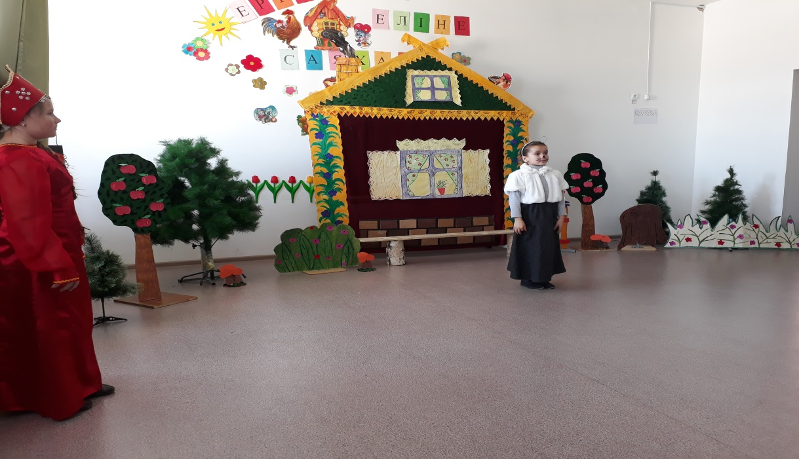

***Ведущая* 1**:There is a house in the wood.

A green frog is running through the wood.

It stops  at the house,

 It knocks at the door.

**Frog:** What a nice house! Tock! Tock! Tock! Who lives in the house?  
  
**Mouse:** I am little mouse. I live in the house. Who are you and what can you do?  
  
**Frog:** I am a green frog.

I can swim and jump. I can skip and turn around. I can run and play.

 May I live in your house?

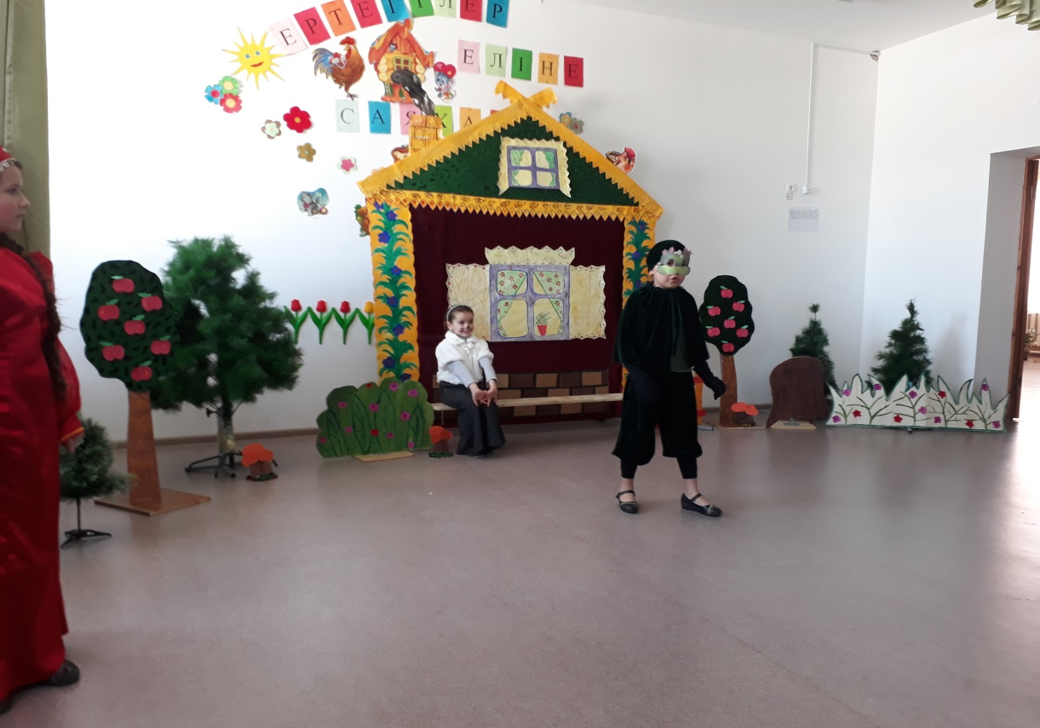

**Mouse:** Of course you may. Come in, please.

**Ведущая**: Here is the house in the wood.

  A Hare is running through the wood.

 It stops at the door,

 It knocks at the door.

**Hare:** What can I see? What a nice house! Who lives in the house? Tock! Tock! Tock!  
**Mouse and Frog:** We do  
**Mouse:** I am a little mouse.  
**Frog:** I am a green frog.  
**Mouse and Frog:** Who are you and what can you do?  
**Hare**: I am a Hare. I can sing and I can play the drum.

**Sing:**  I am funny hare

I’m running in the wood

I’m playing in the drum

I’m jumping on the foot

May I live in our house?

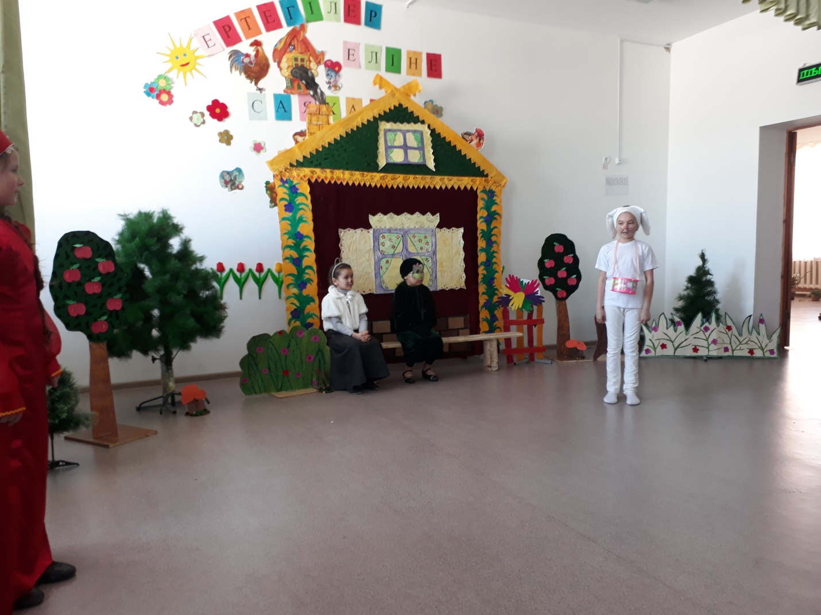

**Mouse and frog**Of course , you may. Come in, please. Welcome to our house!

**Ведущая**: There is the house in the wood.

A red fox  is running through the wood.

 It stops  at the door,

 It knocks at the door.

**Fox:** What a nice house! Who lives in the house? Tock. Tock. Tock.

**Mouse**: I am a little mouse  
**Frog**: I am a green frog.

**Hare**: I am a Hare.  
**Mouse, Frog, Hare**: Who are you and what can you do?

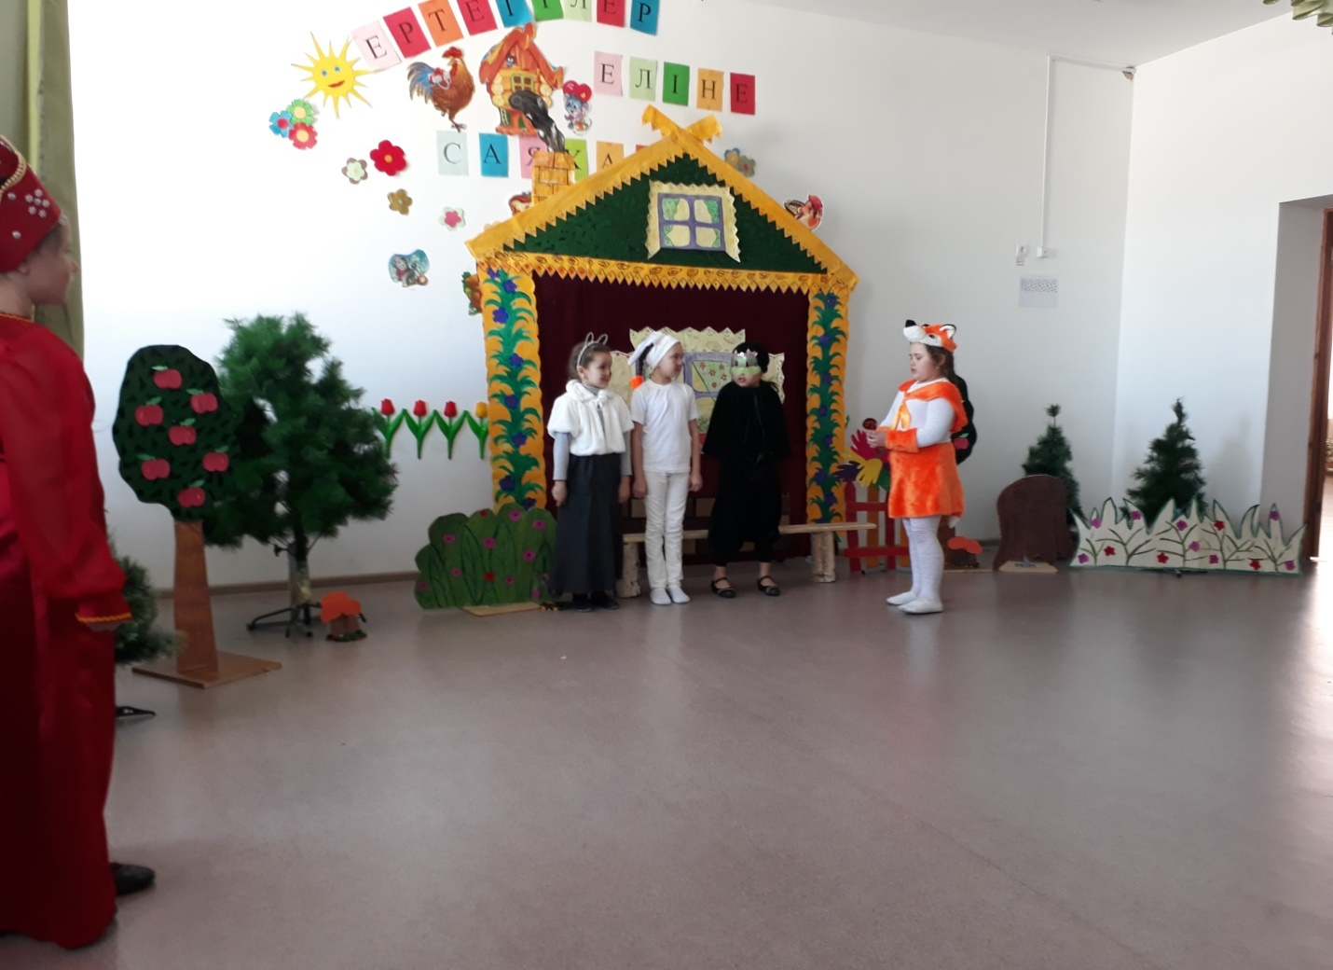

**Fox:**  I am a red fox

I am playing on the spoons

And I am appearing on stage

**Mouse, Frog, Hare:** Come in little fox. Let us play. You may in the house stay. (Dance with spoon)

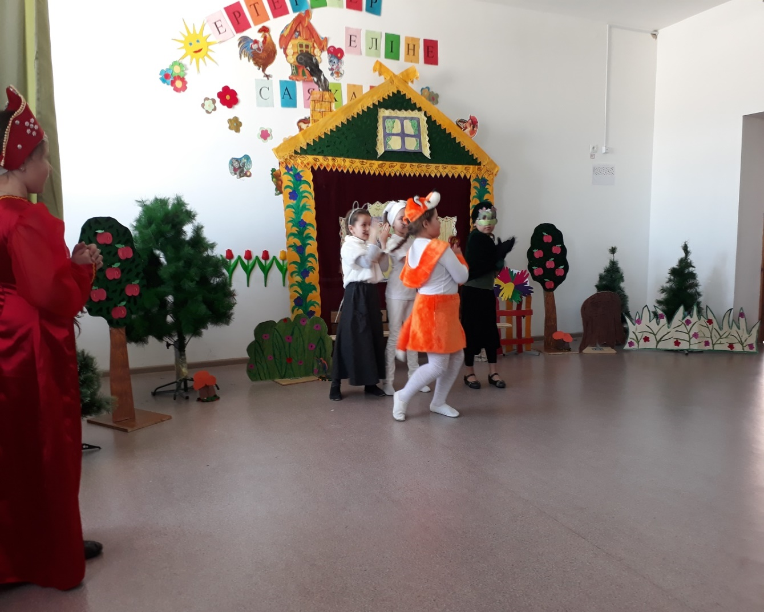

**Ведущая:** There is the big house in the wood.

A grey wolf  is running through the wood.

It stops  at the door,

It knocks at the door.

**Wolf** : What a nice house! Who lives in the house? Tock. Tock. Tock.  
**Mouse**: I am a little mouse.  
**Frog**: I am a green frog.  
**Hare:** I am a Hare.  
**Fox:** I am red fox. **Mouse, Frog, Hare, Fox:** Who are you and what can you do?  
**Wolf**: I am a wolf. I am strong and I am agile. I will be protect and I will be help you. May I live in our house?

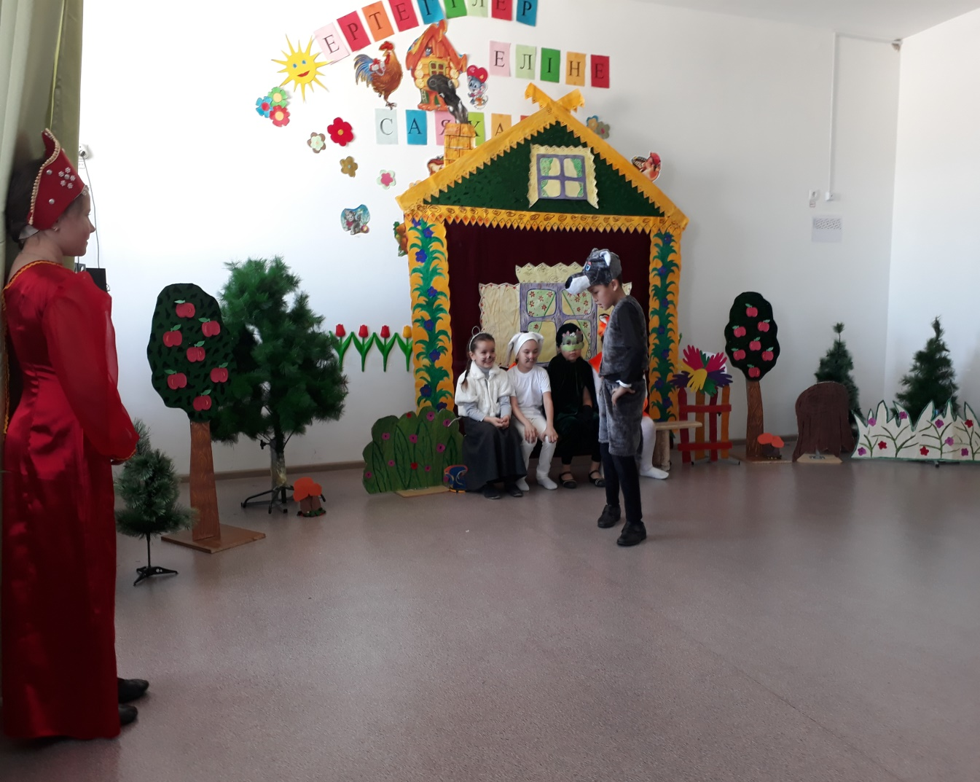  
**Mouse:** Of course , you may. Come in.

**Ведущая** Here is the house in the wood.

A Bear  is running through the wood.

It stops  at the door,

It knocks at the door.

**Bear:** What a nice house! Who lives in the house? Tock. Tock. Tock.

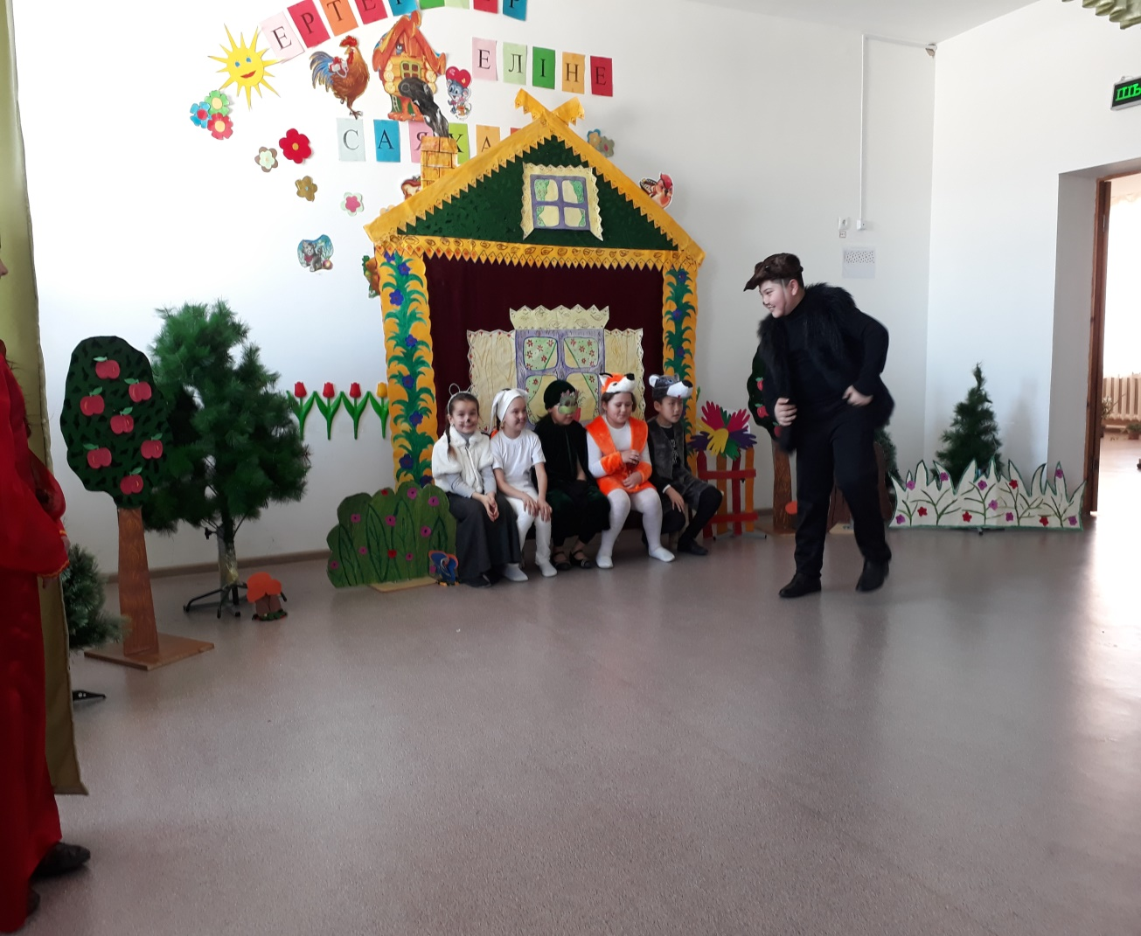  
Mouse: I am a little mouse.  
  
**Frog**: I am a f green frog.  
  
**Hare:** I am a Hare.  
**Fox:** I am a red fox

**Wolf** : I am a grey wolf

**Mouse**: Who are you and what can you do?

**Bear:** I am a bear

I can sing and I can dance

Let’s go my friends

And stand with me

We will merry dance

(Bear’s dance with animal)

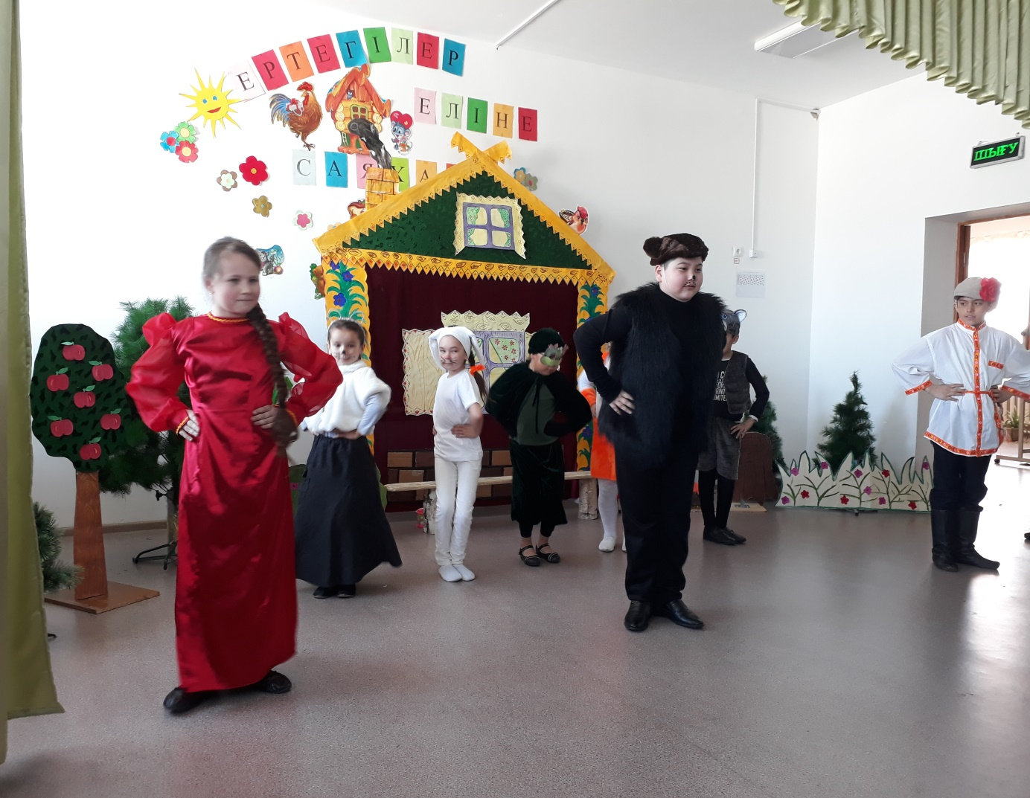  
   
**Ведущая** : Here is a house in the wood. A frog, a mouse, a hare, a fox, a wolf live here! They are happy!!!

**Исполнение песни «The more we are together»**

The more we are together

Together, together

The more we are together

The happier are

For my friend is your friend

And your friend is my friend

The more we are together

The happier we are

The more we sing together

Together, together

The more we sing together

The happier we are

For his friend is my friend

And my friend is his friend

The more we play together

The happier we are

The more we dance together

Together, together

The more we dance together

The happier we are

For our friends are their friends

And their friends are our friends

The more we dance together

The happier we are

The more we dance together

The happier we are

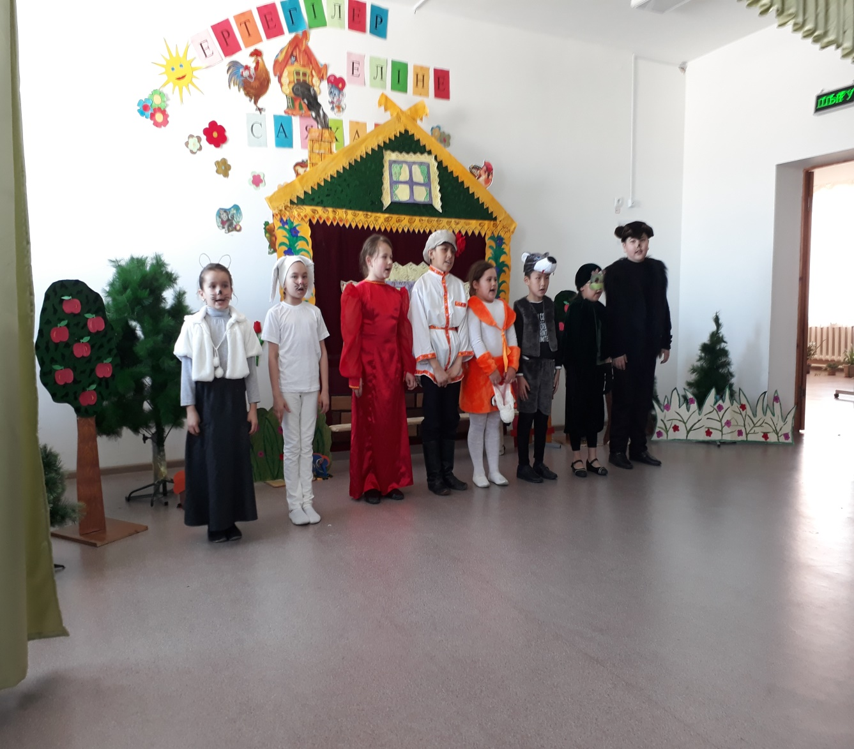

**THE END**